Customer Churn Prediction
Data Gathering, Exploratory Data Analysis & Preprocessing Report

Prepared for: Data Science Project
Date: March 2026
Dataset: Customer_Churn_Data_Large.xlsx

1. Data Gathering & Dataset Selection
This project uses a single Excel workbook containing five interconnected sheets. Each sheet provides a distinct dimension of customer behaviour. All five were selected because together they cover the three key domains known to drive churn: who the customer is (demographics), what they do (transactions and online activity), and how they interact with support (customer service).

1.1 Dataset Overview
Sheet Name | Rows | Key Columns | Role
Customer_Demographics | 1,000 | Age, Gender, MaritalStatus, IncomeLevel | Baseline customer profile
Transaction_History | 5,054 | AmountSpent, ProductCategory, TransactionDate | Purchase behaviour
Customer_Service | 1,002 | InteractionType, ResolutionStatus | Support interactions
Online_Activity | 1,000 | LoginFrequency, LastLoginDate, ServiceUsage | Digital engagement
Churn_Status | 1,000 | ChurnStatus (0/1) | Target variable

1.2 Rationale for Inclusion
- Customer_Demographics: Provides baseline segmentation variables. Age, income level, and marital status are well-established predictors of service switching behaviour.
- Transaction_History: Recency, frequency, and monetary value of purchases are the foundation of RFM analysis — one of the strongest frameworks for predicting churn.
- Customer_Service: Complaint frequency and unresolved issues are direct indicators of customer dissatisfaction, a primary churn driver.
- Online_Activity: Login frequency and days since last login measure engagement. Low engagement is a leading indicator of disengagement before formal churn.
- Churn_Status: The target variable. Binary label (1 = churned, 0 = retained) required for supervised classification model training.

1.3 Merging Strategy
All five sheets share CustomerID as the primary key. Transaction_History and Customer_Service contain multiple rows per customer and must be aggregated before merging. All merges use LEFT JOIN with Customer_Demographics as the anchor table to ensure all 1,000 customers are retained regardless of whether they appear in supplementary sheets.

Sheet | Before Merge | After Merge | Notes
Transaction_History | 5,054 rows | 1,000 rows | Aggregated: sum, mean, count, mode, max date
Customer_Service | 1,002 rows | 1,000 rows | 332 customers had no record — NaN filled with 0
Online_Activity | 1,000 rows | 1,000 rows | Direct merge — no aggregation needed
Churn_Status | 1,000 rows | 1,000 rows | Direct merge — target variable

2. Exploratory Data Analysis

2.1 Descriptive Statistics
Following the merge, the master dataset contains 1,000 rows and 17 columns with zero missing values. The table below summarises key statistics for all numeric features.

Feature | Mean | Median | Std Dev | Min | Max | Skew
Age | 43.3 | 43.0 | 15.2 | 18 | 69 | Low
TotalSpend (£) | 1,197 | 1,136 | 668 | 9.8 | 3,386 | Low
AvgSpend (£) | 248.8 | 250.1 | 79.4 | 9.8 | 497.0 | Low
NumTransactions | 5.05 | 5.0 | 2.6 | 1 | 9 | Low
LoginFrequency | 25.9 | 27.0 | 14.1 | 1 | 49 | Low
DaysSinceLastLogin | 181.4 | 181.5 | 105.7 | 1 | 365 | Uniform
NumComplaints | 0.33 | 0.0 | 0.49 | 0 | 2 | Right

Categorical Feature Summary
Column | Distribution
Gender | Female: 513 (51.3%) | Male: 487 (48.7%)
MaritalStatus | Widowed: 276 (27.6%) | Married: 261 (26.1%) | Divorced: 248 (24.8%) | Single: 215 (21.5%)
IncomeLevel | High: 349 (34.9%) | Medium: 326 (32.6%) | Low: 325 (32.5%)
ServiceUsage | Online Banking: 349 (34.9%) | Mobile App: 342 (34.2%) | Website: 309 (30.9%)
FavCategory | Books: 313 (31.3%) | Clothing: 226 (22.6%) | Electronics: 182 (18.2%)
ChurnStatus | Retained (0): 796 (79.6%) | Churned (1): 204 (20.4%)

2.2 Visualisations
Figure 1 shows the distribution of key numeric features and churn rates across demographic segments.

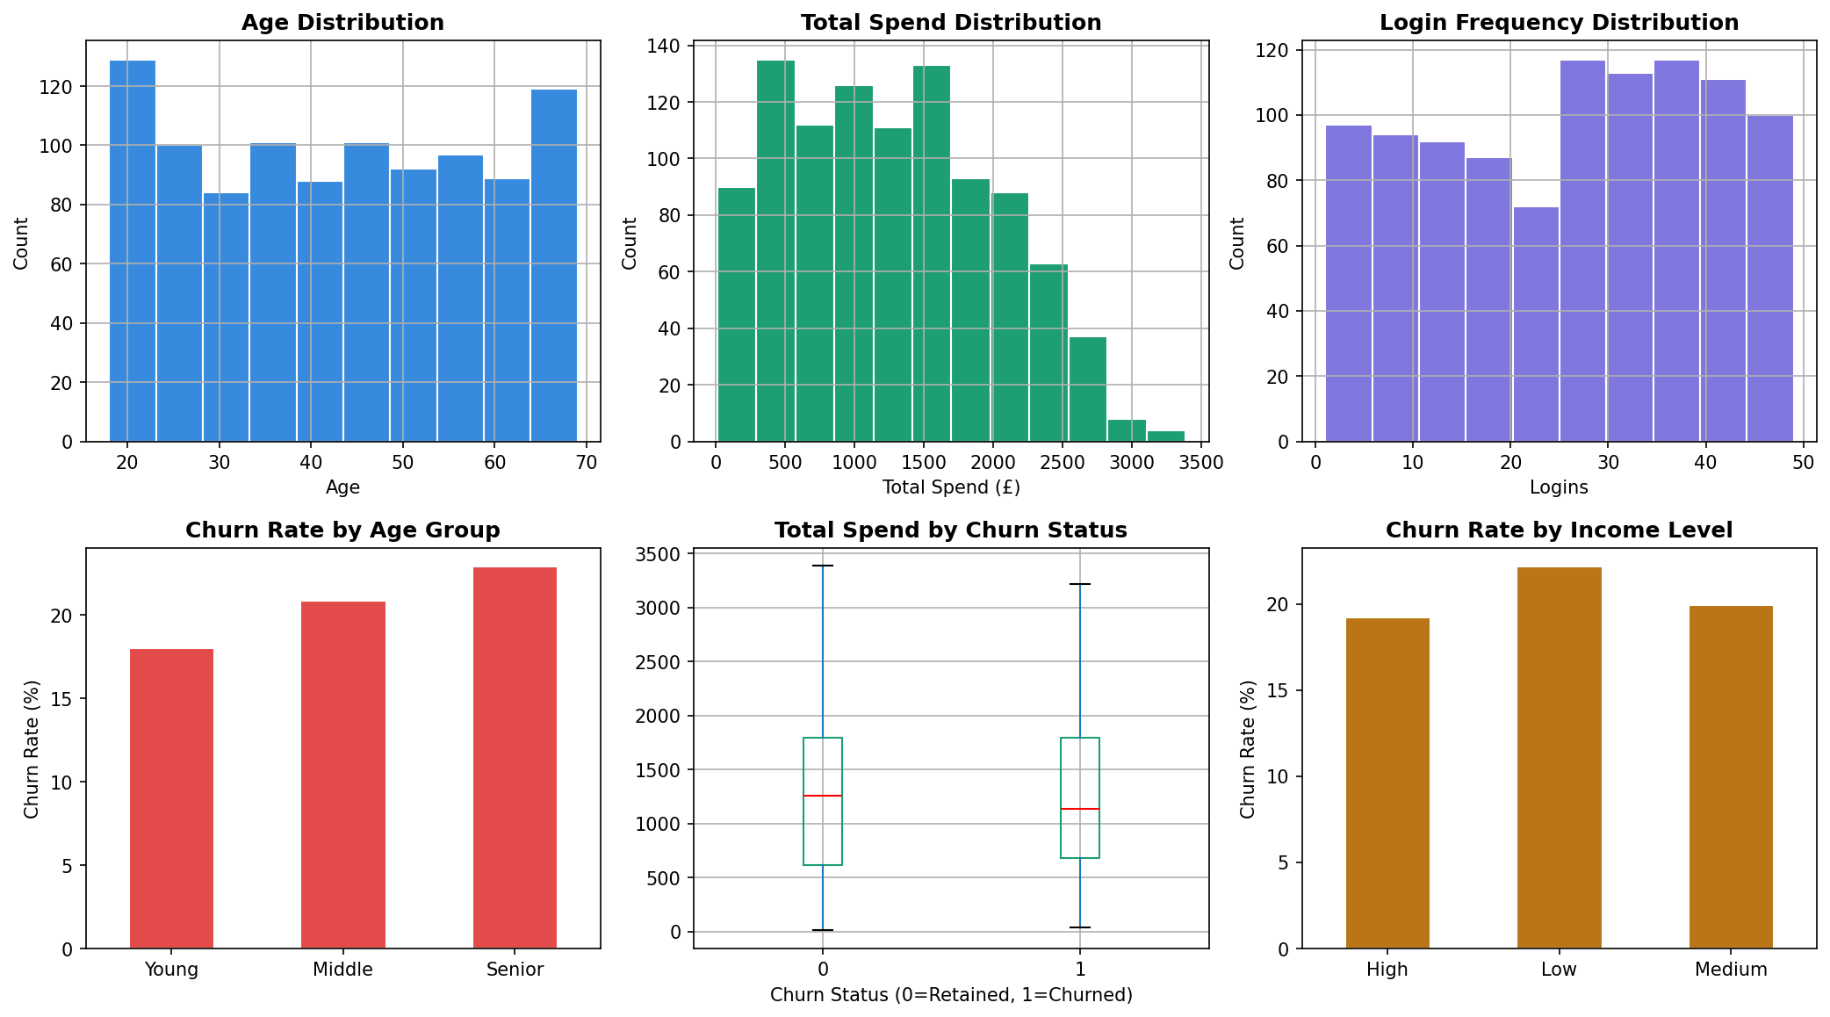
Figure 1: Feature distributions and churn rates by demographic group

Figure 2 shows the churn distribution and breakdown by gender and marital status.

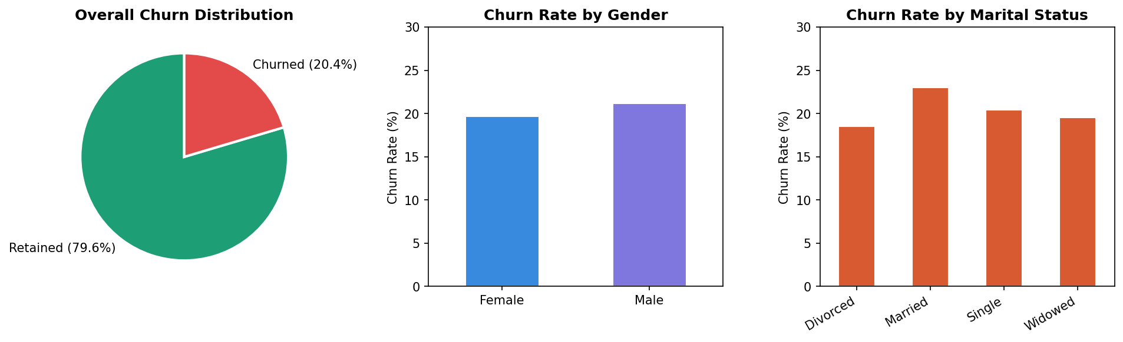
Figure 2: Churn distribution and breakdown by key demographic variables

2.3 Correlation Analysis
After encoding categorical variables, Pearson correlation coefficients were calculated for all numeric features against ChurnStatus. Figure 3 shows the full correlation matrix.

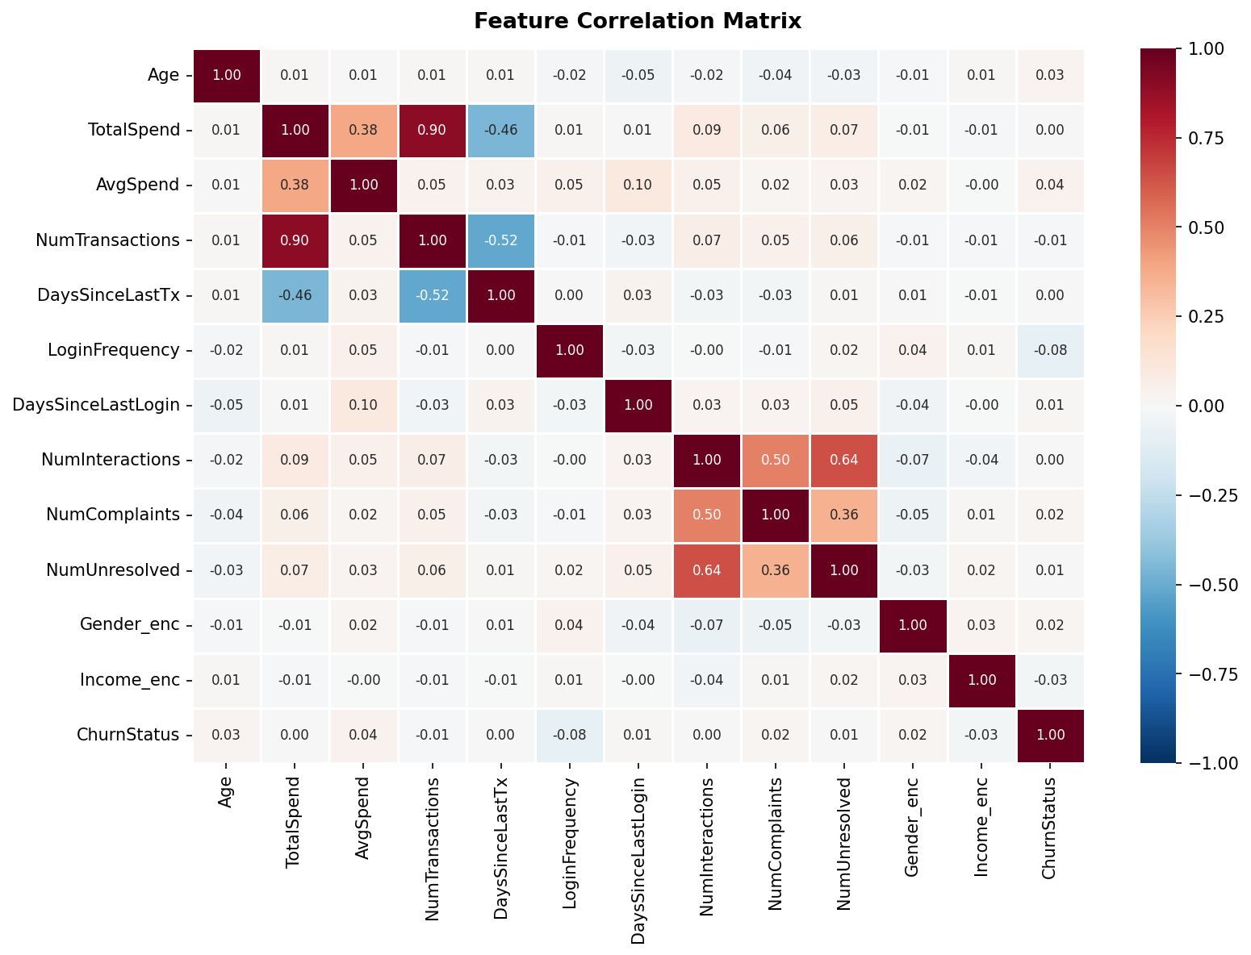
Figure 3: Feature correlation matrix

Key Correlation Findings
Feature | r vs Churn | Interpretation
LoginFrequency | -0.082 | Strongest predictor — low engagement precedes churn
AvgSpend | +0.045 | Higher average spend slightly associated with churn
Income_enc | -0.030 | Lower income customers churn marginally more
Age | +0.029 | Older customers churn slightly more than younger
NumComplaints | +0.017 | More complaints weakly associated with higher churn

Note: All individual correlations are weak (|r| < 0.1). This is typical in real-world churn datasets where churn is driven by combinations of features rather than any single variable. Tree-based ensemble models such as Random Forest and XGBoost, which capture feature interactions, are expected to outperform linear classifiers on this dataset.

2.4 Key Insights from EDA
- Churn rate is 20.4% — a moderately imbalanced binary target. Standard accuracy is not a reliable evaluation metric; AUC-ROC and F1-score must be used.
- Senior customers (56-69) churn at 22.9% versus 18.0% for young customers (18-35), suggesting age is worth retaining as a feature.
- Low-income customers churn at 22.2% versus 19.2% for high-income, a modest but consistent pattern.
- Login frequency is the single strongest individual predictor (r = -0.082). Customers with fewer logins are more likely to churn.
- 332 customers (33.2%) had no customer service record — their absence of contact may itself be an informative signal of disengagement.
- Product category preferences are relatively uniform, suggesting category alone is not a strong churn differentiator.

3. Data Cleaning & Preprocessing

3.1 Missing Value Treatment
The raw data contained zero missing values across all five sheets. However, the LEFT JOIN merge introduced 332 NaN values in the Customer_Service derived columns for customers who had no service interaction record. These were handled using the flagging and fill strategy described below.

Column | NaN Count | Strategy | Justification
NumInteractions | 332 | Fill with 0 | No contact record = 0 interactions
NumComplaints | 332 | Fill with 0 | No contact record = 0 complaints
NumUnresolved | 332 | Fill with 0 | No contact record = 0 unresolved
HasServiceRecord | N/A | New binary flag | 1 = had contact, 0 = never contacted support

3.2 Outlier Detection & Treatment
The IQR method (Tukey fences: Q1 - 1.5*IQR and Q3 + 1.5*IQR) was applied to all numeric features. Figure 4 shows box plots for three key numeric columns.

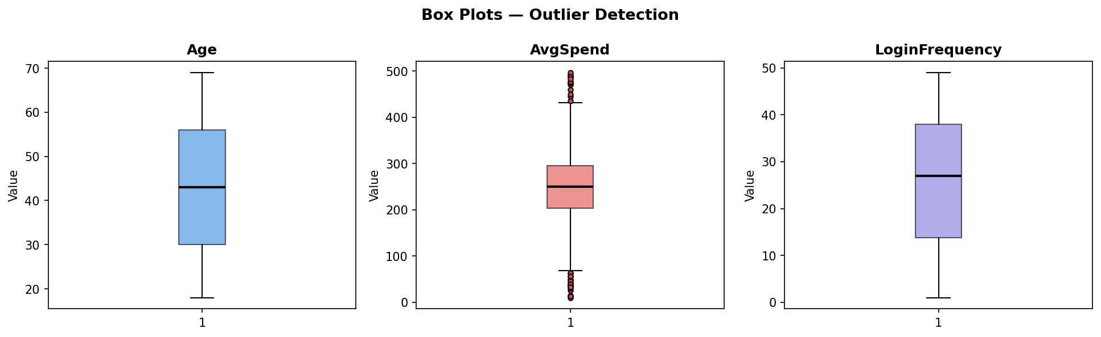
Figure 4: Box plots for Age, AvgSpend, and LoginFrequency

Feature | Low Outliers | High Outliers | Decision | Rationale
Age | 0 | 0 | No action | Range 18-69 is naturally bounded
TotalSpend | 0 | 0 | No action | Range reflects legitimate variation
AvgSpend | 23 | 15 | Cap (Winsorise) | Driven by single-transaction customers; clip to 5th-95th percentile
NumTransactions | 0 | 0 | No action | Range 1-9 is expected
LoginFrequency | 0 | 0 | No action | Range 1-49 is expected
DaysSinceLastLogin | 0 | 0 | No action | Range 1-365 is naturally bounded

3.3 Categorical Encoding
All categorical columns were converted to numeric form using the encoding method most appropriate for each column's data type.

Column | Method | Output | Justification
Gender | Label encoding | M=1, F=0 | Binary — no ordering issue
MaritalStatus | One-hot (drop_first) | 3 binary columns | 4 nominal categories — no natural order
IncomeLevel | Ordinal encoding | Low=0, Med=1, High=2 | Natural order exists
ServiceUsage | One-hot (drop_first) | 2 binary columns | 3 nominal categories — no natural order
FavCategory | One-hot (drop_first) | 4 binary columns | 5 nominal categories — no natural order

3.4 Feature Engineering
Five new features were created to capture relationships not directly expressed by the raw columns.

Feature | Formula | Purpose
AgeGroup_enc | pd.cut(Age, bins=[17,35,55,70]) | Captures non-linear relationship between age and churn
SpendPerTx | TotalSpend / NumTransactions | Spend intensity per visit, independent of transaction volume
ComplaintRate | NumComplaints / NumInteractions | Proportion of contacts that were complaints — more nuanced than raw count
IsHighRisk | LoginFrequency<10 AND NumComplaints>0 | Combines two weak signals into a single high-risk flag (51 customers)
HasServiceRecord | NumInteractions > 0 | Preserves the informational value of never having contacted support

3.5 Normalisation
All 12 numeric feature columns were standardised using Z-score standardisation (StandardScaler) to give each feature a mean of 0 and standard deviation of 1. This ensures no single feature dominates model training due to scale differences. Binary and ordinal encoded columns were not scaled as they are already on a bounded scale.

4. Final Cleaned Dataset

4.1 Dataset Summary
Total rows | 1,000
Total features (excl. target) | 26
Target variable | ChurnStatus (0 = retained, 1 = churned)
Missing values | 0
Numeric features (scaled) | 12
Engineered features | 5
Encoded categorical features | 9
Churn rate | 20.4% (204 churned / 796 retained)

4.2 Feature List
Feature | Type | Source / Notes
Age | Numeric (scaled) | Customer_Demographics
TotalSpend | Numeric (scaled) | Aggregated from Transaction_History
AvgSpend | Numeric (scaled) | Aggregated — Winsorised at 5th/95th percentile
NumTransactions | Numeric (scaled) | Aggregated from Transaction_History
DaysSinceLastTx | Numeric (scaled) | Engineered from TransactionDate
LoginFrequency | Numeric (scaled) | Online_Activity
DaysSinceLastLogin | Numeric (scaled) | Engineered from LastLoginDate
NumInteractions | Numeric (scaled) | Aggregated from Customer_Service
NumComplaints | Numeric (scaled) | Aggregated — NaN filled with 0
NumUnresolved | Numeric (scaled) | Aggregated — NaN filled with 0
SpendPerTx | Numeric (scaled) | Engineered: TotalSpend / NumTransactions
ComplaintRate | Numeric (scaled) | Engineered: NumComplaints / NumInteractions
Gender_enc | Binary | M=1, F=0
Income_enc | Ordinal | Low=0, Medium=1, High=2
AgeGroup_enc | Ordinal | Young=0, Middle=1, Senior=2
IsHighRisk | Binary | Engineered: low login + complaints flag
HasServiceRecord | Binary | Engineered: ever contacted support
MS_Married, MS_Single, MS_Widowed | Binary (one-hot) | MaritalStatus — Divorced is baseline
SU_Online Banking, SU_Website | Binary (one-hot) | ServiceUsage — Mobile App is baseline
FC_Clothing, FC_Electronics, FC_Furniture, FC_Groceries | Binary (one-hot) | FavCategory — Books is baseline
ChurnStatus | Binary (TARGET) | 0 = retained, 1 = churned

4.3 Recommended Next Steps
- Address class imbalance (80/20 split) using SMOTE oversampling or class_weight='balanced' in the model — do not evaluate with accuracy alone.
- Train baseline models: Logistic Regression, Random Forest, and XGBoost. Compare on AUC-ROC and F1-score.
- Use feature importance scores from Random Forest or XGBoost to identify and potentially drop low-importance features.
- Consider cross-validation (k=5) to ensure model performance is not sensitive to train/test split.
- The cleaned dataset (Churn_Model_Ready.xlsx) is included as a separate deliverable and is ready for immediate model training.

